INVENTION DISCLOSURE FORM

Please indicate each inventor’s information.
(A new table should be added for each inventor.)

Inventor’s Name and Surname:

Institution/Company:

Contribution of the invention (as percentage)

Address:

ID Number:

E-mail:

Inventor’s Name and Surname:

Institution/Company:

Contribution of the invention (as percentage)

Address:

ID Number:

E-mail:

I. TECHNICAL INFORMATION

1. Disclosure Date:

2. What is the title of your invention?

3. Describe your invention briefly (max 200 words).

4. In which technical area will your invention be used?

5. Have you published, presented, patented or otherwise disclosed this invention already? If yes, please indicate the date and the name of organization/publication.

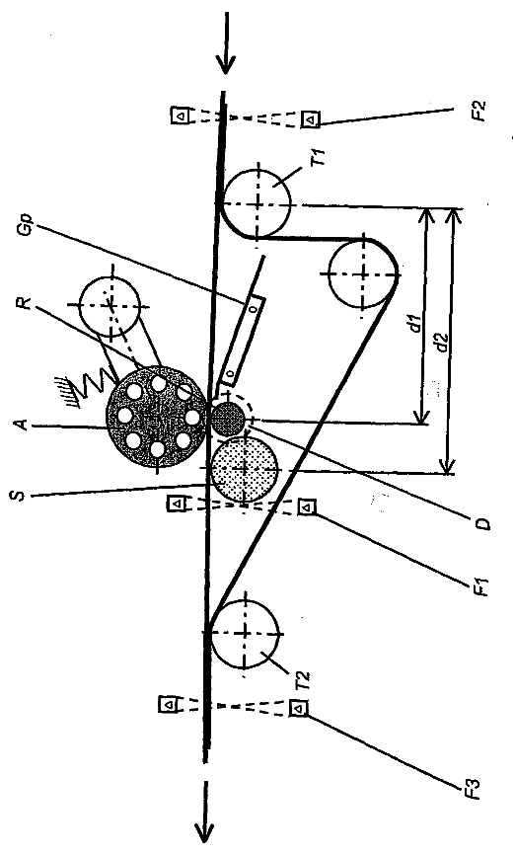
6. Please form a reference table by pointing out the elements which is partaking in your invention
EXAMPLE

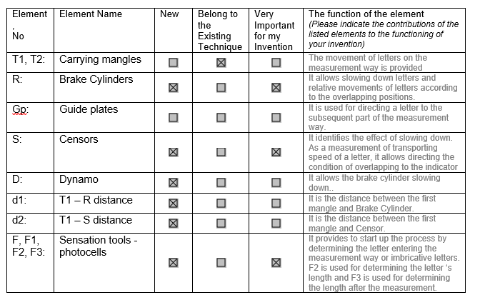
6.1. The photos of your invention:
(Please use an additional page if necessary)

6.2. The elements partaking in your invention:
(Please fill in the below table by viewing the above sample table. Please insert new rows if the information does not fit on the table.)

Element,  No | Element Name | New | Belong to the existing technique | Very important for the invention | The function of the element  (Please indicate the contributions of the listed elements to the functioning of your invention)
1.
2.
3.
4.
5.
6.
7.

6.3. Process steps:
(Please sort the process steps which form your invention or are used in production process to form your invention. Please indicate the said process steps and the its relations to the elements by using below sample table.)
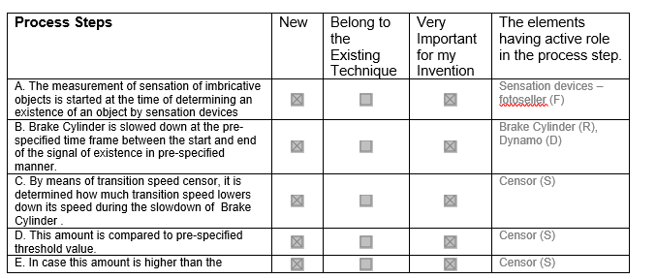
Process Steps | New | Belong to the existing technique | Very important for the invention | The elements having active role in the process step.
A.
B.

C.

D.

E.

6.4. Sum up of invention’s operating logic or principle by referencing the elements. (Please explain by referencing to the part numbers. The advantages of your invention are obtained with which elements.)

7. The keywords to be used in preliminary patent search. (Local or international company names that work in the same technical area, websites, and sources that may help understating of your invention, if any.)

8. Please indicate patents, articles and/or publications that you think relevant to your invention.

9. What are the deficiencies and inadequacies of existing techniques?

10. What are the benefits of your invention? Please give details of its advantages and contributions compare to the existing technique.

11. Is your invention supported by any project of government funding (TEYDEB, H2020 or any others)?

ATTACHMENT

II. COMMERCIALIZATION & MARKET INFORMATION

12. Which problem are you solving with your technology? Please explain the problem.

13. Who is your target customer? Please explain who will use your product/service or technology. Have you talked to any of your customers about the problem, if yes please explain?

14. How does your target customer solve this problem right now? Is there any current solution to this problem, how does you target customer solving the problem now? Who are your direct, indirect competitors and who might become competitors? Please list the current solutions and competitors with bullet points.

15. Please list top 3 the industries and contact names (if there is any) that needs your technology. Please give actual company examples for each industry.

16. Do you think your invention team is interested in for the improvement of the invention? Do the inventors have required technical expertness, business skills and enthusiasm to develop the idea into a marketable product?

17. Have you ever try to commercialize the invention in the related market? If yes, when and with which companies?

18. Are there any competitors for the subject of invention in the market? Do you think the competitors in the related market is strong?

19. What kind of risks or barriers are there in the market for commercialization of the invention?

20. Will commercialization of this idea produce immediate or long-term cash returns?

21. Do you already own a company? If not would you consider to establish a startup company for the commercialization of the invention if the TTO supports you? YES/NO

III. IPR INFORMATION

22. Is your invention an output of a collaboration project with an industry or any company?

23. Do you think your invention infringe with third party’s IP rights or patents?

24. Do you have an opinion about the share of the invention between your team members?

25. Is there any agreement or undertaking regarding the invention? If yes, with whom or which company?

